Open Ended problem-1 --- DSIP

Name:- Slock Ahuja
Enroll No:- 92400133041

- Discrete Time Periodic Sequence 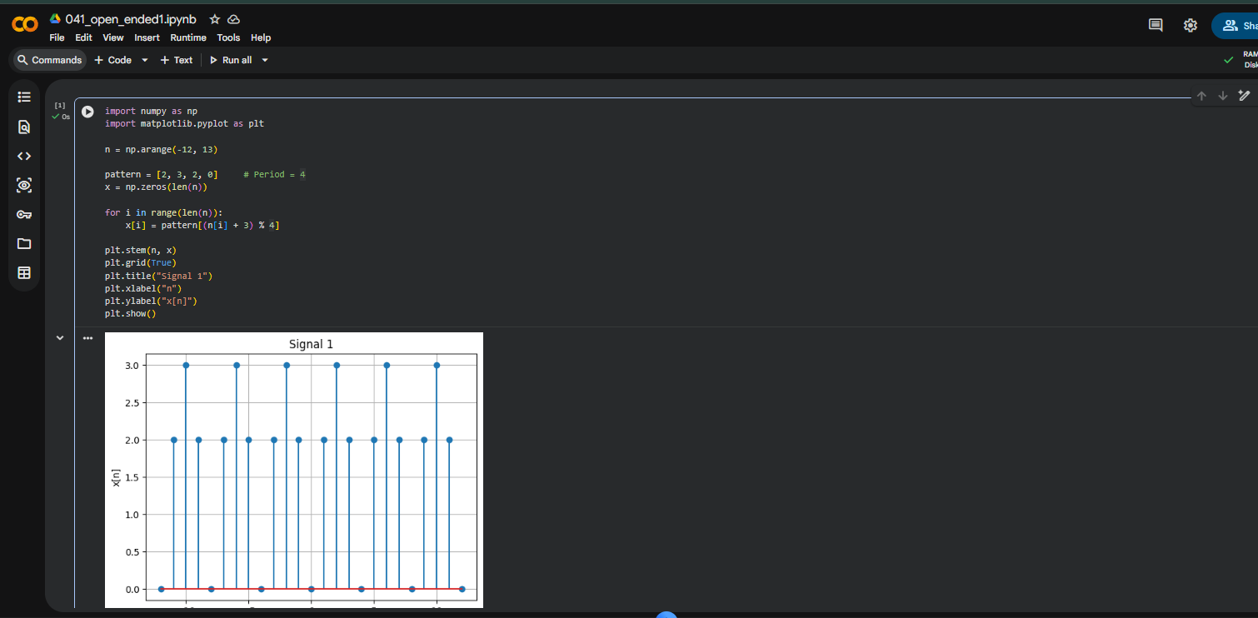

- Staircase Signal

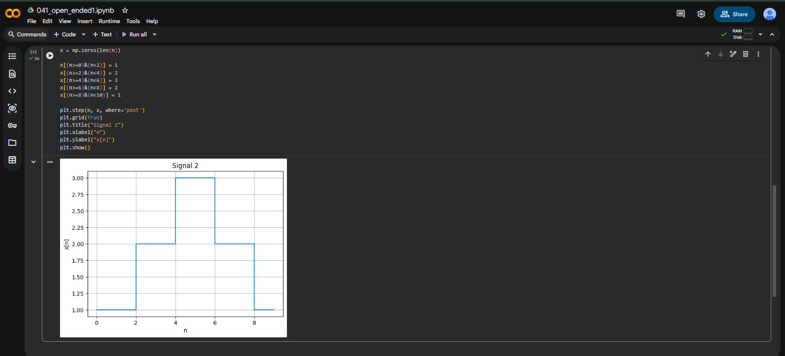

- Piecewise Signal

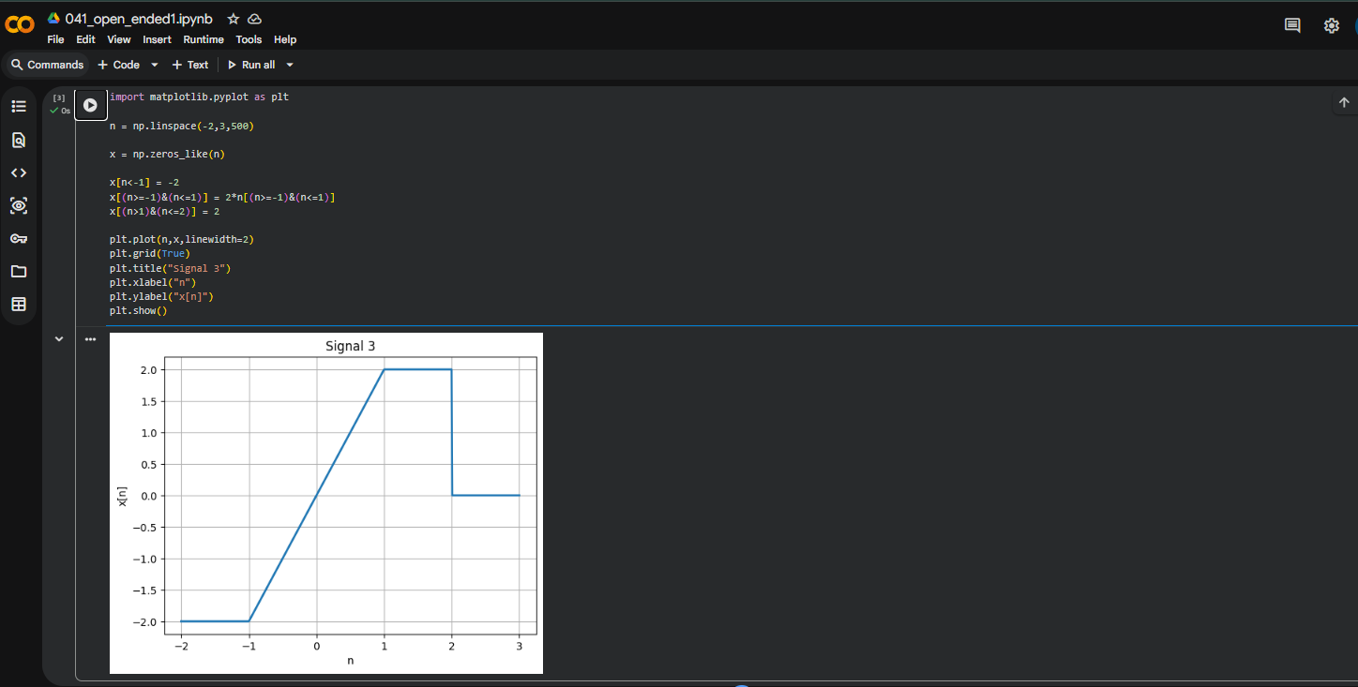

- Unit-Step Signal

$$\text{x}\text{[}\text{n}\text{]=}\text{u}\text{(}\text{n}\text{)−}\text{u}\text{(}\text{n}\text{−3)−5}\text{u}\text{(}\text{n}\text{−7)}$$

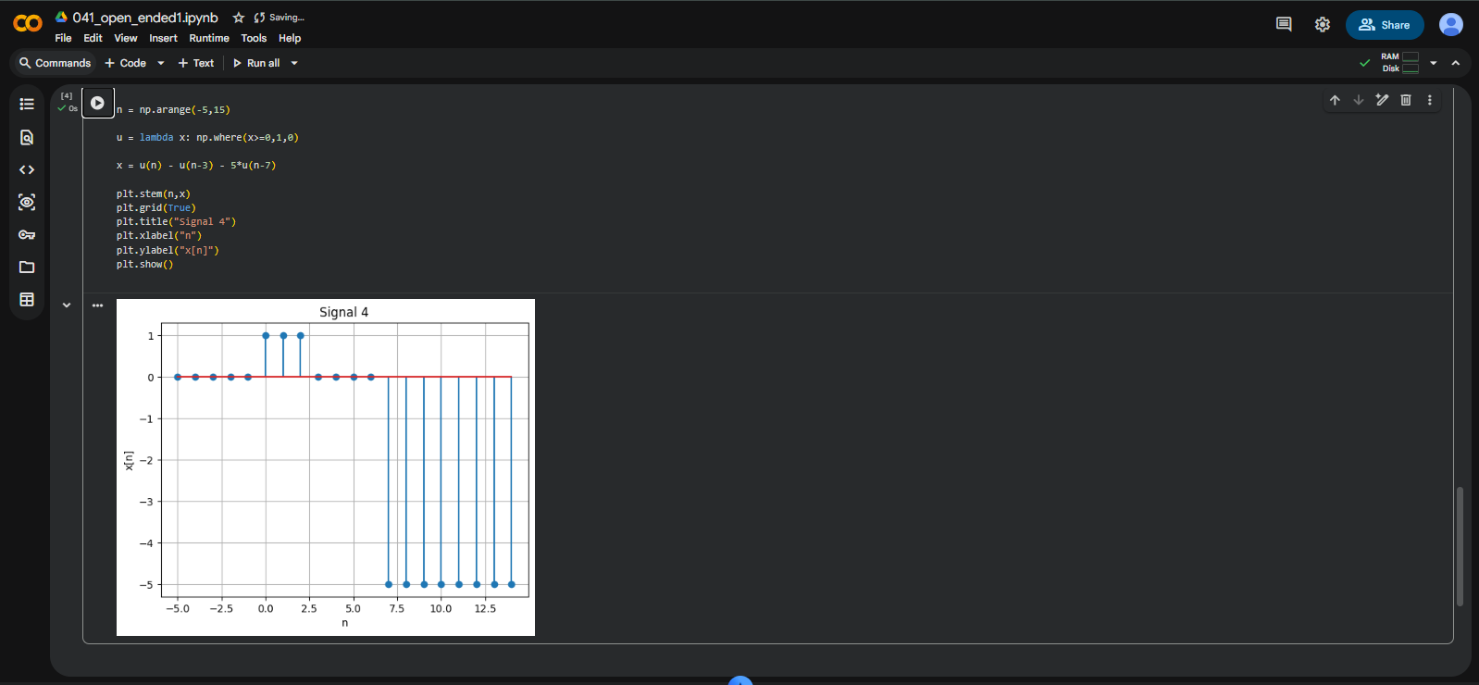

- Impulse Signal
$$\text{x}\text{[}\text{n}\text{]=}\text{δ}\text{(}\text{n}\text{)+3}\text{δ}\text{(}\text{n}\text{−1)+5}\text{δ}\text{(}\text{n}\text{+1)}$$
